Module 2: Baseline Assessment

Session 8: Wealth Breakdowns

Handout 1 – Wealth Breakdowns

What is a wealth breakdown?
- A clustering of people into common wealth groups.

- A wealth group is a set of households that employ the same general strategies for obtaining food and income. They live at roughly the same level of wealth and have the same capacity to cope with hazards.

Example of a wealth breakdown:
Chongwe-Nyimba Plateau Valley Livelihood Zone, Zambia
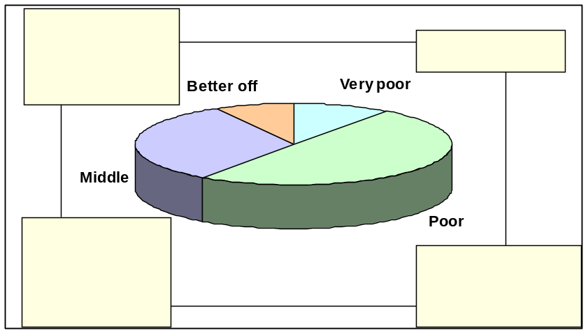
Source: Zambia Vulnerability Assessment Committee, Zambia Livelihood Map Rezoning and Baseline Profiling, Lusaka, Zambia. October 2004.

Why do we need to divide the population up in this way?
- People’s wealth - what they have by way of land, capital and livestock, together with their educational status and access to political and social networks - determines the ways in which they will be able to get food and cash.
- For example, poor households with little land may work for better-off households to get money to buy food; the better-off may use profits from agriculture as capital to engage in trade.
- These differences also determine the effect that either sudden or long-term change will have on households, and the strategies households are able to employ to cope.

How do we define wealth groups?
- In the field, wealth categories are defined through interviews with community key informants.
- The population is divided into at least three (commonly four and sometimes more) wealth groups. The level of division depends on how the community view their society, and the purpose of the analysis.
- ‘Poor’ and ‘better-off’ are defined relative to local standards, not to an externally defined one. We are interested in descriptions of wealth groups within a defined community.

What criteria are used to define wealth groups?
- Criteria are developed with key informants on the basis of ‘drivers’ or generators of wealth (such as land, labour, or capital), rather than the end result, or indicators of wealth (such as roofing type or clothing). Typical examples include:
  - ownership of cattle, pack animals or other animals
  - land ownership/rental or the amount of land cultivated per season
  - the number of wives/size of family/size of household; including the balance between young and mature children.
  - the ability to employ others or reliance upon working for others
  - income sources
  - assets and savings
  - agricultural input/means of production

Typical determinants of wealth in a pastoral and agricultural society
  - In an agricultural society, wealth is likely to be associated with land ownership or amount of land cultivated. It is likely to be linked to livestock ownership as well, since people tend to store their wealth ‘on the hoof’ in agricultural areas where banks are few or unreliable. In these societies factors related to land access and use are more likely to appear in the wealth ranking, with richer households: owning larger pieces of land, renting parcels to others or from others (depending on local policies of land tenure), hiring others as agricultural labourers, and possibly owning equipment which is used to cultivate large farms.
  - In a pastoral society, wealth may be primarily determined by the size of one's cattle herd. Key informants may identify 'rich' households as being those with more than 50, 100 or 150 cattle. Other characteristics of the 'rich' may derive from these cattle holdings - e.g. heavy reliance on drinking milk for meeting their energy needs, selling ghee in the market to buy cereals, employing others to work as herding boys, or greater likelihood for men to have multiple wives (because they are able to pay the cattle dowry). 'Middle' households will have fewer cattle, less food and cash deriving from cattle, less ability (and need) to employ others to watch their herd, and perhaps fewer wives. Depending on the typical cattle holdings in the area, the 'poor' may include those who have no cattle at all, or it may be split into those with small herds and those without cattle. One may notice that land ownership, which is an important determinant of wealth in agricultural societies, may have no meaning whatsoever to purely pastoralist populations who do not farm, and for whom grazing land is plentiful.
  - In addition to land, livestock and labour, wealth is determined by:
- A household’s political assets (relationships with powerful interests and ability to use these relationships to its economic advantage); and
- A household’s social assets (relationships within the community).

What about the very poorest and very richest households?
- HEA tends not to involve detailed inquiry into the very poor households at the extreme end of the wealth spectrum. These are the very poorest (destitute) households that are largely dependent on charity and tend not to be economically active.
- The very richest households - the ‘richest of the rich’ - constitute such a small minority of the population that detailed income and expenditure information for these households tends in many cases not to be necessary.
- However, in some contexts, interviews with this group can provide a lot of useful information – especially where a very small proportion of households own the vast majority of wealth and where much of the rest of the population is therefore tied to this group through various kinds of economic or social arrangements. In such a context, putting a percentage to the very rich group reveals a skewed distribution of wealth that in itself tells us a great deal about how the local economy works and what it means to be poor.

Things to keep in mind
- Make sure in your discussions with key informants you are talking about the same type of household, whether it consists of a husband with all his wives and dependants or a wife living away from (but still economically linked to) her husband.
- Bear in mind that the terms ‘rich’ and ‘poor’ are loaded with subjective pre-conceptions and should be avoided. It is often easier to talk about those who have to work for others, or those who are better off. Use the same terms your informants use and let them define the wealth groups in local terms.
- Wealth groups are different from ‘vulnerable’ groups. You are not grouping people into the typical ‘vulnerable’ categories, like ‘women, children, disabled’. It is important to be very clear about this in your interviews with informants, who may have been previously asked for beneficiary lists like this, and who may assume you want the same thing.
- If household size varies with wealth (for example, poorer households might tend to be smaller because of labour constraints), the % of the population will differ from the % of households.

Steps in carrying out a wealth breakdown interview

- Find the right people to ask
First, seek out the village leader(s) and explain the purpose of the visit and what you would like to do. Explain that you would like to meet with a group of 6-8 men and women who can explain the overall situation of people living in the area.

- Agree on determining criteria (land/livestock/labor)
The types of questions that can be used to start the wealth breakdown include:
- We know that households are not all living in exactly the same way – what is it that makes one household better or worse off than another in this area?
- What are the different characteristics of people who are doing well, or not doing well, in this area?
In this way, you can agree on the main criteria - land, livestock or labour - that determine wealth in that community. Further prompting will lead to discussions and estimates of household size and asset ownership.

- Decide on reasonable cut off points

- Use proportional piling to group

- Divide further if necessary
If one group is very large - say, over 40% - you should sub-divide it, asking your key informants to describe differences within the group.

Wealth breakdown tips
- Explain that we know that there are differences within every community – not all households are the same – some are better-off, some are worse off.
- For our purposes, ‘poor’ means poorer than most households, while ‘better-off’ means better-off than most households (in practical terms this means the ‘poor ‘ can not constitute more than 50% of the population).
- In this interview we are not just concerned with this village, we are concerned with the area in general.
- If informants say that ‘everyone is the same now’, then ask them about differences within the community one year (or more) ago.
- If, after proportional piling, one group looks very large, ask the key informants to explain differences within the group and encourage them to subdivide the pile.

Extract from Interview Form 3 for Mock Wealth Breakdown Interview
Wealth groups: local definitions and names (local language) |  |  | Vanoshaisisa | Vanoshaya |  |  | Vanowanawo |  | Vanowana
Wealth group name (English) |  |  | Very poor | Poor |  |  | Middle |  | Better off
No. wives per husband (if polygamous society) |  |  | 1 | 1 |  |  | 1 |  | 1
Household size  - Minus those living away  + Plus those from other households |  |  | 4 | 6 |  |  | 6 |  | 6
Land owned  (grazing + crop, including cash crop) |  |  | 5 - 6 ha | 5 - 6 ha |  |  | 5 - 6 ha |  | 5 - 6 ha
Land rented in / out

Land cultivated (owned +/-  rented land) | Total area |  | ½ - 1 acre | 1 - 5 acres |  |  | 5 - 8 acres |  | 6 hectares
Land cultivated (owned +/-  rented land) | Food crops area |  | ½ - 1 acre | 1 - 5 acres |  |  | 3 - 6 acres |  | 3 acres
Land cultivated (owned +/-  rented land) | Cash crops area |  |  |  |  |  | 2 acres |  | 3 acres
Main crops grown for sale |  |  |  | Maize |  |  | Maize, cotton, tobacco |  | Maize, cotton, tobacco
Main crops grown for food |  |  | Maize, sweet potatoes, groundnuts | Same as v. poor |  |  | Same plus beans |  | Same plus beans
Livestock:  Cattle owned |  | Total (range) | 0 | 0-2 |  |  | 2-7 |  | 8+
 |  | Prod. females |  | 0 |  |  | 1-2 |  | 3
 |  | Plough oxen |  | 0 |  |  | 2 |  | 4
Goats owned |  | Total (range) | 0 | 0-2 |  |  | 3-6 |  | 5+
 |  | Prod. females |  | 0 |  |  | 2 |  | 4
Sheep owned |  | Total (range)
 |  | Prod. females
Livestock loans/tending agreements
(under what type of arrangement?)
Other livestock: |  |  | 0-5 chickens | 1-4 chickens |  |  | 10+ chickens |  | 10+ chickens
Other livestock:
Other causes of differences in production (e.g. quality of land, access to irrigation, labour, agric. inputs etc) |  |  |  |  |  |  |  |  | Can hire labour
Other productive household assets (e.g. ploughs, irrigation, trees, hives, enset stems, fishing equipment) |  |  |  |  |  |  | Own plough |  | Own plough
Main sources of cash income, ranked  Checklist of cash income sources: |  |  | Casual labour (agricultural and other)  Gifts | Casual labour (agricultural and other)  Crop (vegetable sales)  Petty trade  Chicken sales |  |  | Crop sales  Livestock and livestock product sales  Remittances |  | Crop sales  Livestock and livestock product sales  Remittances
- Agricultural labour  - Other casual labour (e.g. construction)  - Paid domestic work  - Salaried employment |  |  | - Remittances  - Firewood collection or charcoal burning  - Collection and sale of wild foods  - Mining |  |  | - Crop sales  - Vegetable sales  - Brewing  - Petty trade (small-scale trade) |  | - Trade (large scale)  - Small business  - Fishing  - Transport (e.g. taxi, pick-up)
Months of consumption from own harvest |  |  | 4 months |  | 9 months |  | > 12 months (surplus) |  |  | > 12 months (surplus)
Bad year response strategies |  |  | Increased reliance on gifts  Little scope to cut back |  | Took children out of secondary school.  No purchase of clothes, utensils or other non-essentials |  | Defaulted on input credit  Generally get by |  |  | Less affected than other groups.  Reduced spending on luxuries.
Schooling levels attained by children |  |  | Primary |  | Primary + occasionally secondary |  | Secondary for some children |  |  | Secondary for all children + some tertiary
% of households in each wealth group (proportional piling) |  |  | 3 |  | 20 |  | 65 |  |  | 15
Main constraints and  development priorities → |  |  | Clinics, schools, water sources  Seeds |  | Same as v. poor. |  | Clinics, schools, water sources  Tillage  Access to credit for inputs |  |  | Same as middle

Last step: Selection of participants for interview from the different wealth groups. Ask the community leaders to organise 3-5 people from each wealth group. At least half of the participants or groups should be women. Explain that you will be interviewing each group separately. Arrange meeting times and a location for each group.

